Cyclistic Bike-Share Case Study Presentation

# Slide 1: Title Slide

* Title: Cyclistic Bike-Share Analysis
* Subtitle: How do annual members and casual riders use Cyclistic bikes differently?
* Presented by: [Your Name]
* Date: July 2025

# Slide 2: Business Task

* Understand how annual members and casual riders use Cyclistic bikes differently.
* Goal: Provide actionable insights to help convert casual riders into annual members.

# Slide 3: About Cyclistic

* Over 5,800 bikes and 600 docking stations in Chicago
* Offers inclusive options (reclining bikes, hand tricycles, cargo bikes)
* Rider Types:
* - Casual Riders: Single-ride or full-day passes
* - Members: Annual subscriptions

# Slide 4: Data Source

* 12 months of historical trip data from Cyclistic (Divvy)
* Public data from Motivate International Inc.
* Data cleaned, merged, and analyzed in Excel

# Slide 5: Data Cleaning Process

* Removed null/blank values from key columns
* Dropped irrelevant columns (IDs, lat/long)
* Created new columns: ride_length, day_of_week
* Ensured consistency in formats and removed duplicates

# Slide 6: Total Rides by Rider Type

* - Members take significantly more rides
* - Indicates strong engagement and daily utility

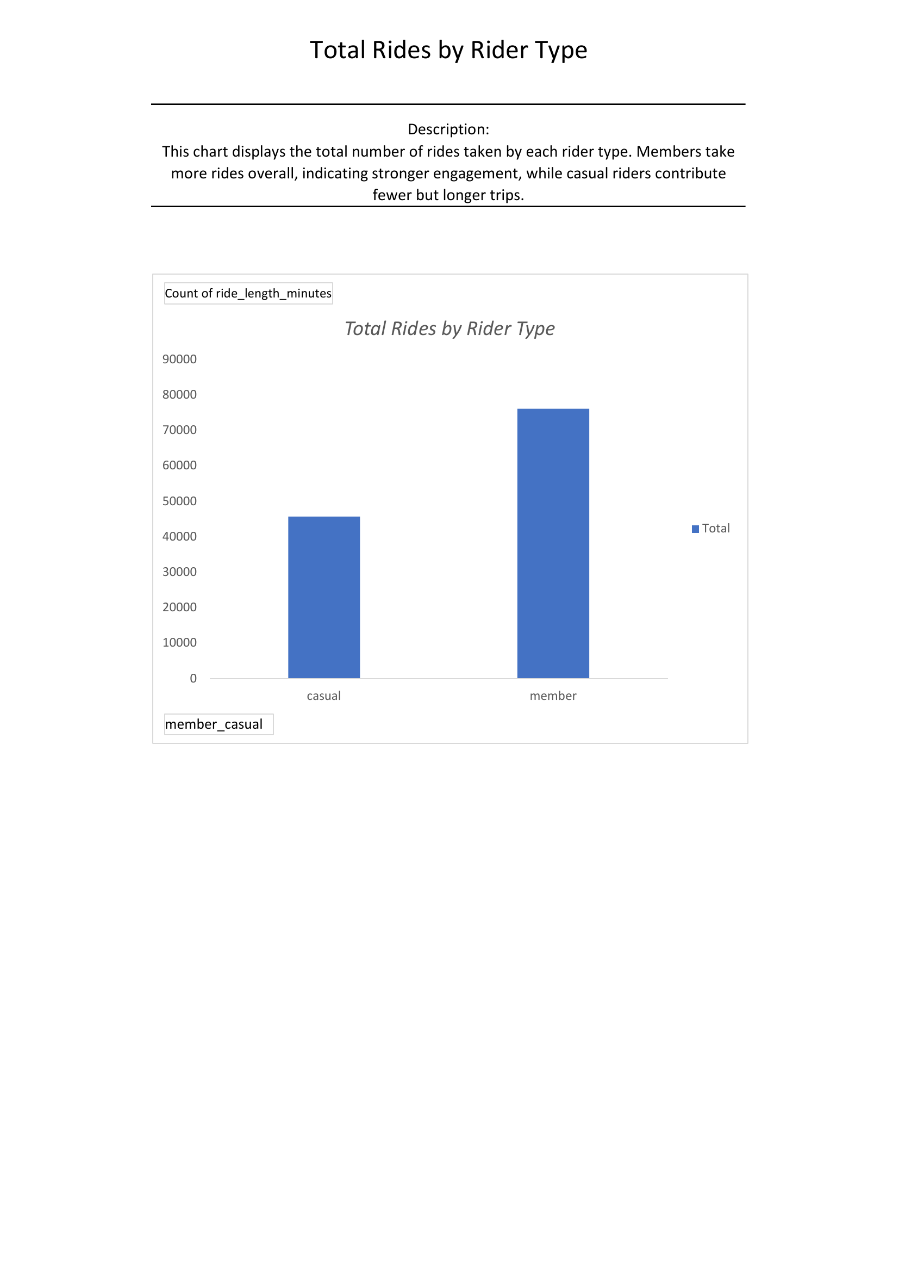

# Slide 7: Rides by Weekday

* - Members ride more during weekdays (commute)
* - Casual riders peak on weekends (leisure)

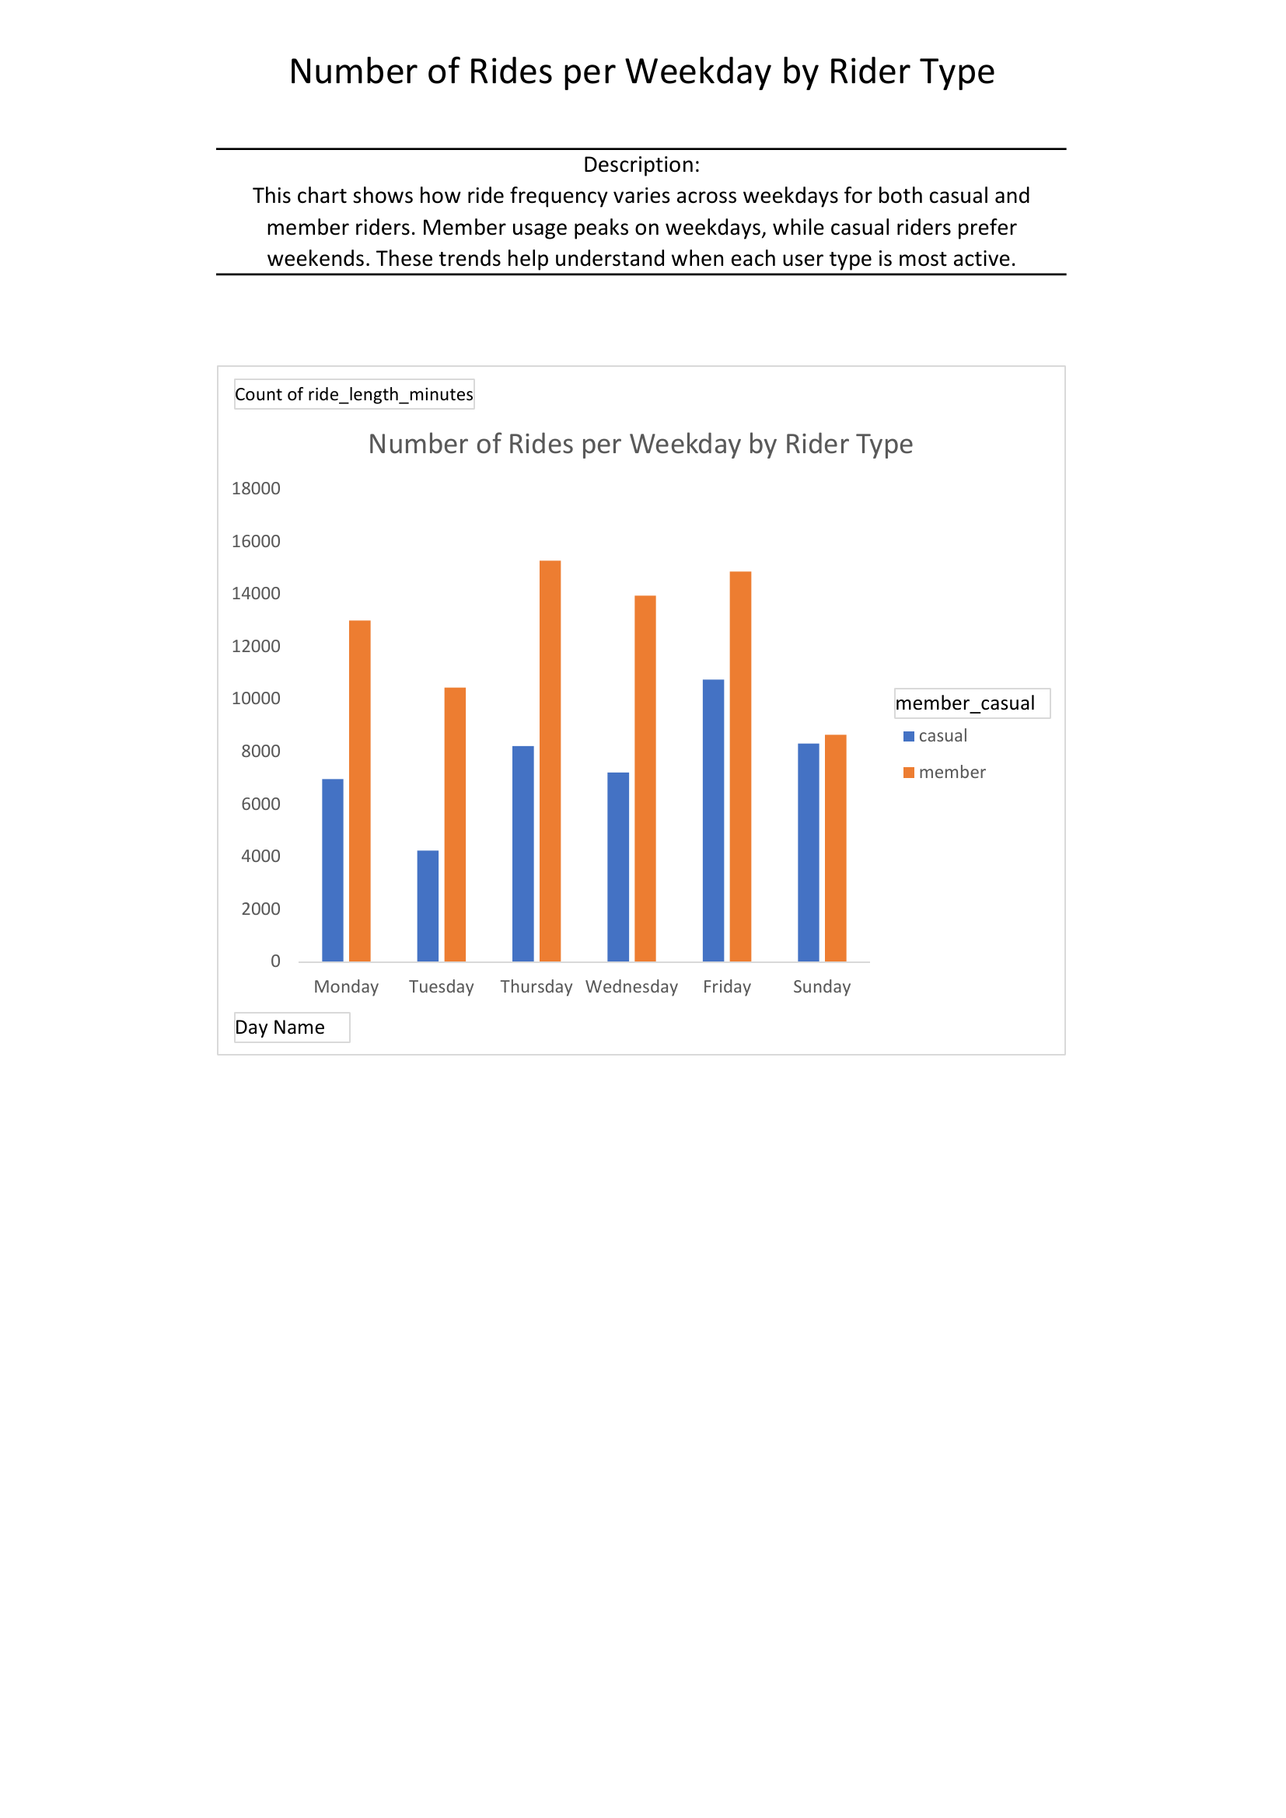

# Slide 8: Average Ride Duration

* - Casual rides last longer on average
* - Suggests leisure usage vs. utility-focused short trips for members

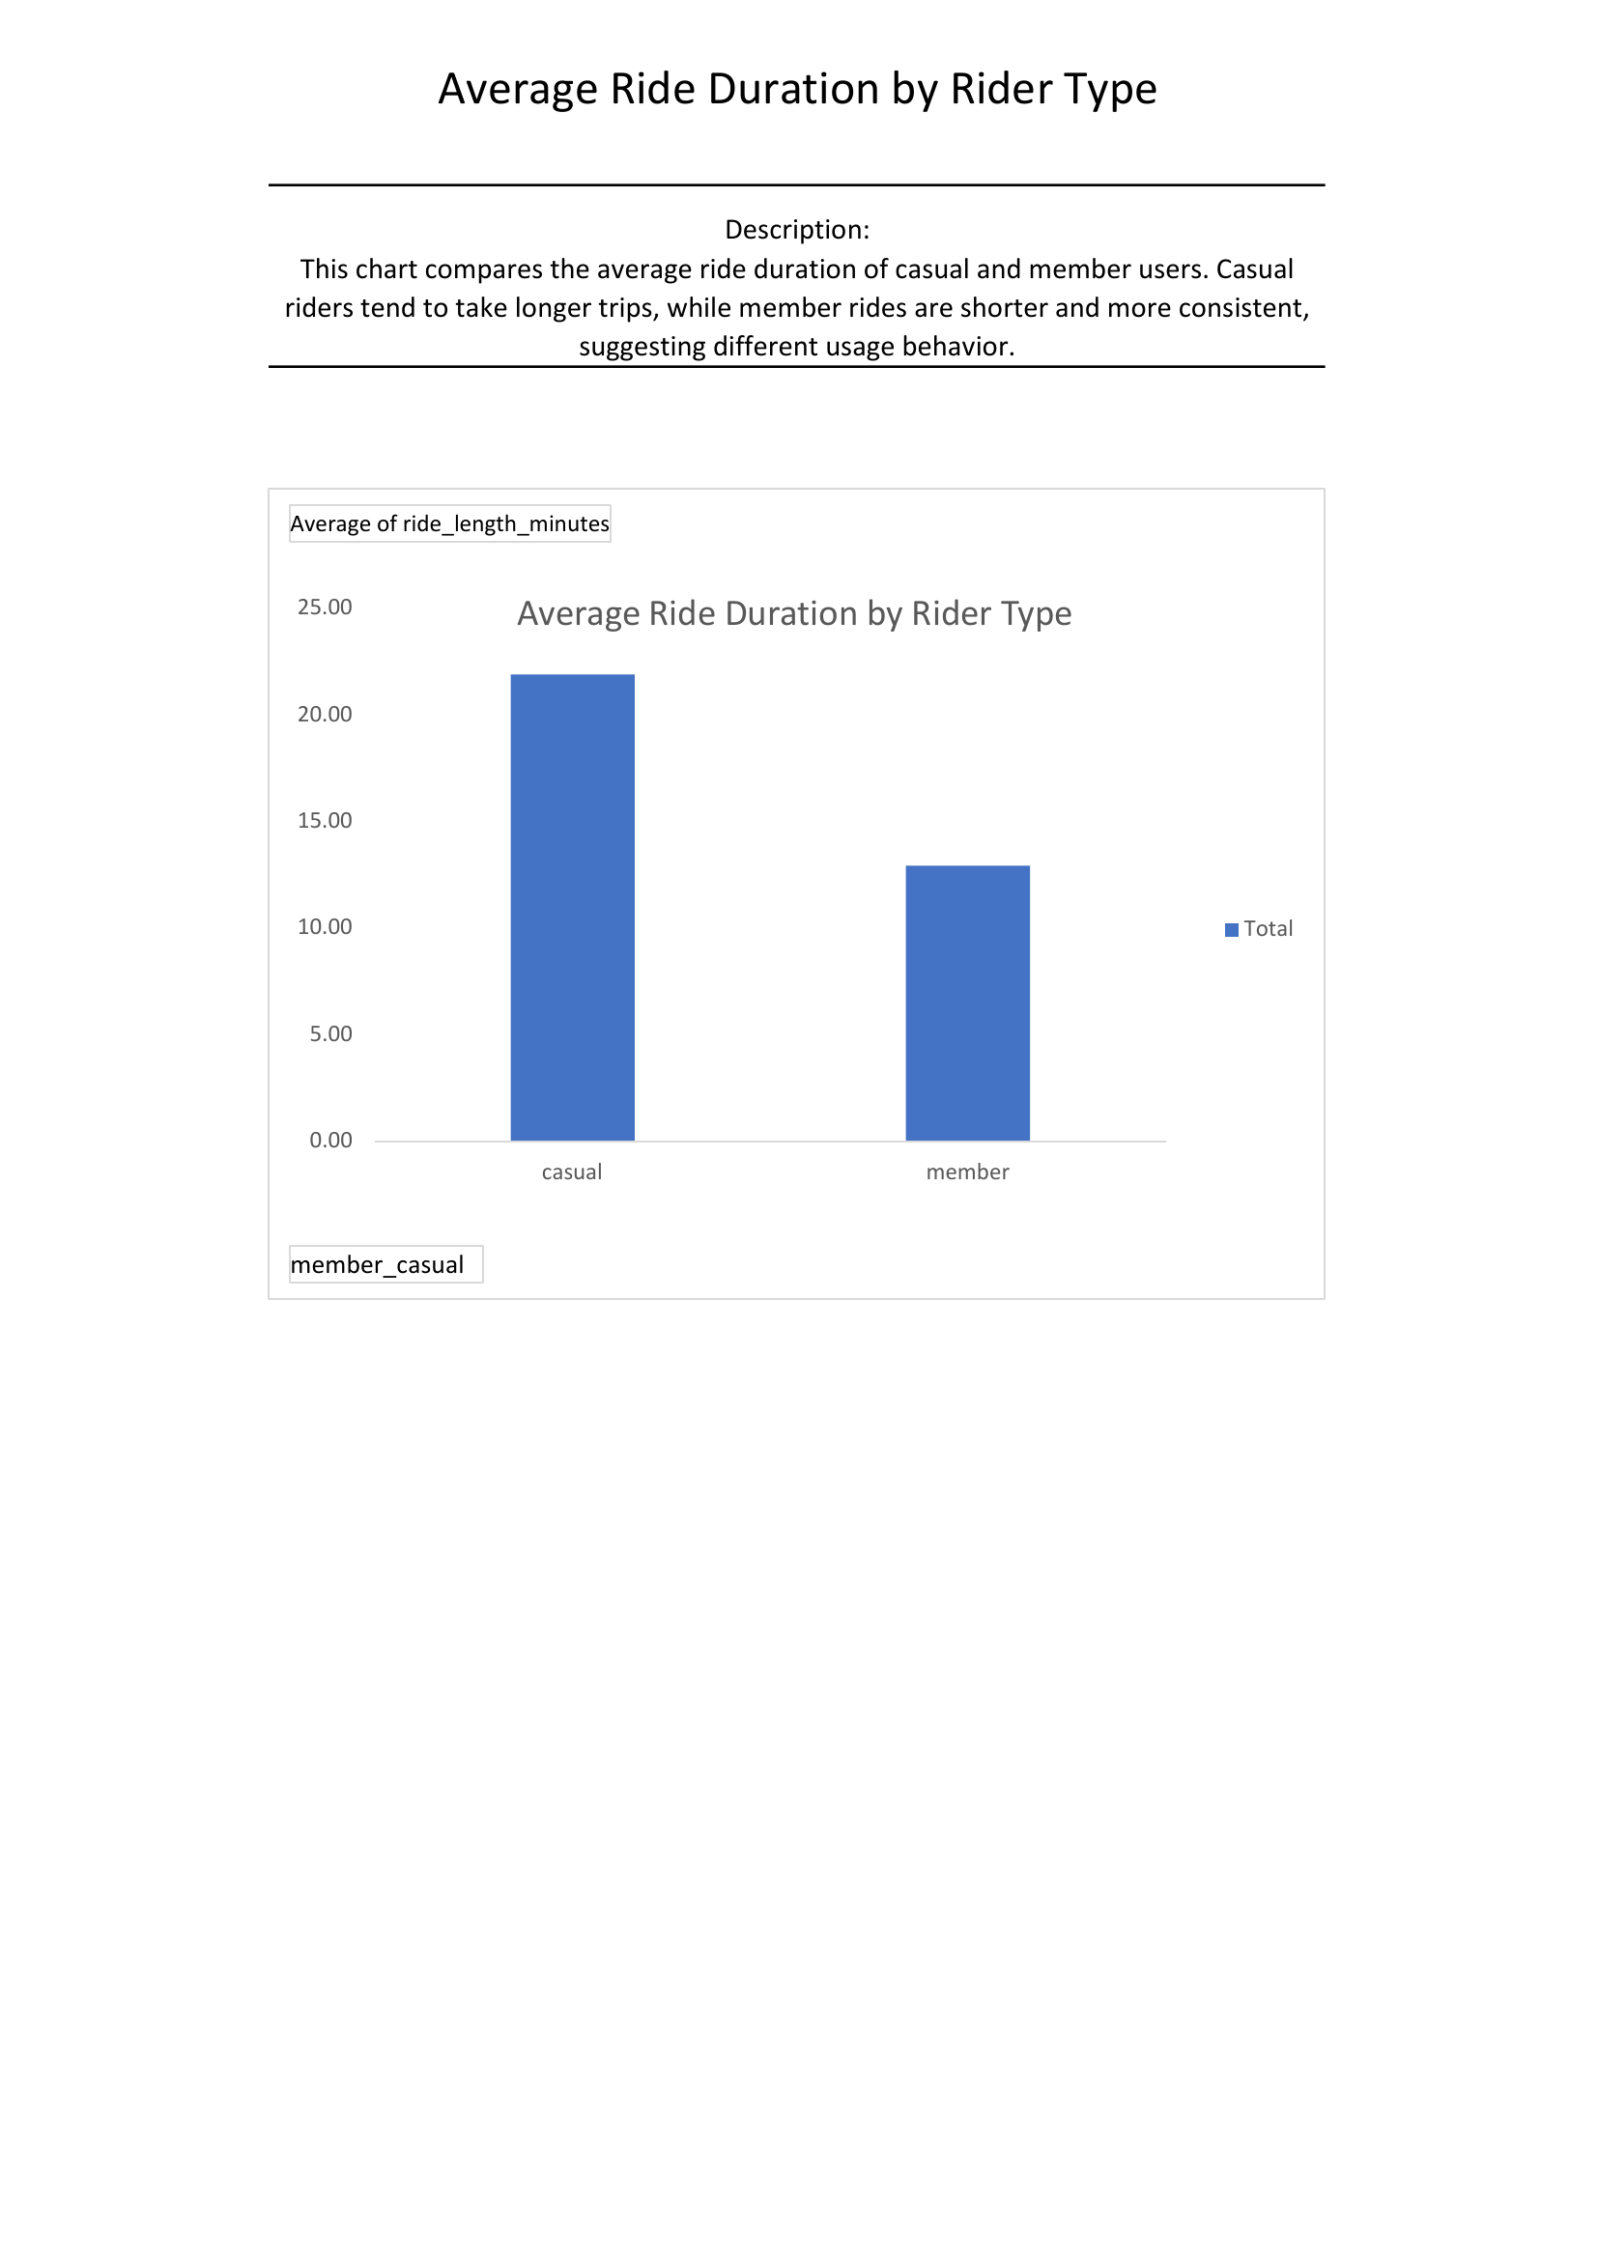

# Slide 9: Key Insights Summary

* - Members ride more frequently and during weekdays
* - Casual riders ride longer and prefer weekends
* - Usage pattern shows behavioral differences that can guide strategy

# Slide 10: Recommendations

* 1. Weekend Membership Promotions: Encourage weekend casual users to join
* 2. Improve Bike Availability: Ensure bikes at key locations during casual peak times
* 3. Trial Membership Offers: Convert high-usage casual riders with time-limited discounts

# Slide 11: Next Steps

* - Use digital marketing to target casual users with tailored offers
* - Run pilot campaigns and track impact
* - Explore further data dimensions (time-of-day, location, bike type)

# Slide 12: Thank You

* Questions?
* [Your Contact Info or Team Info]